L1 Support

Do the login

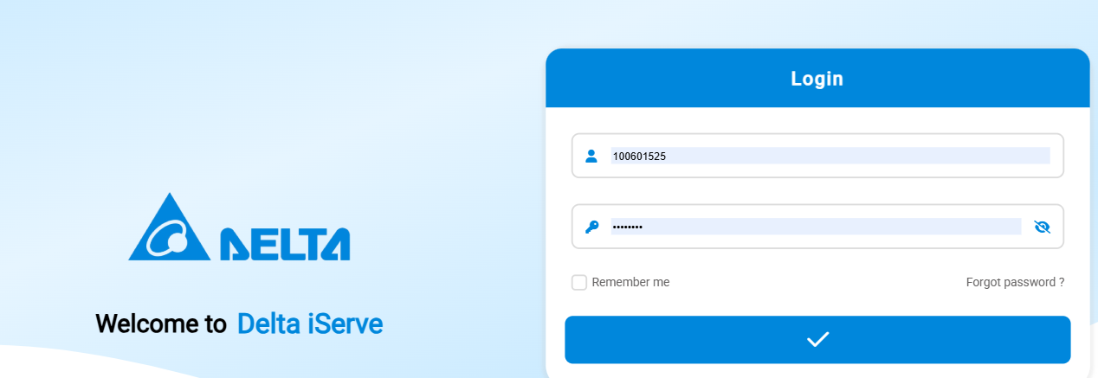

Go to service call management – service contract

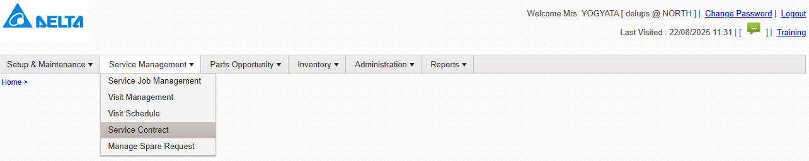

Click on add

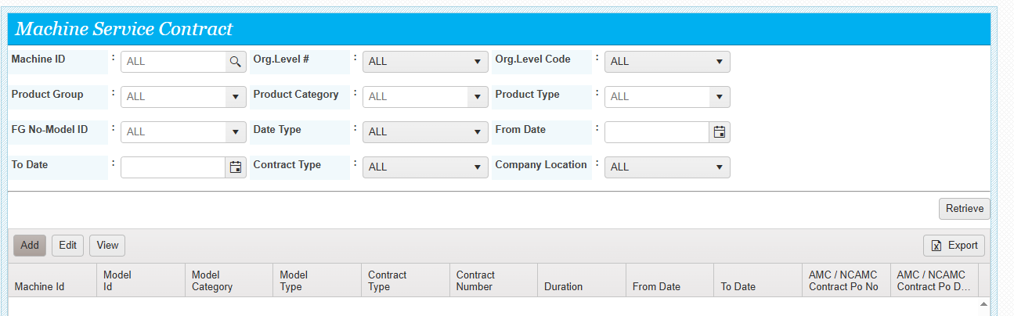

Enter the machine no and select the contract type

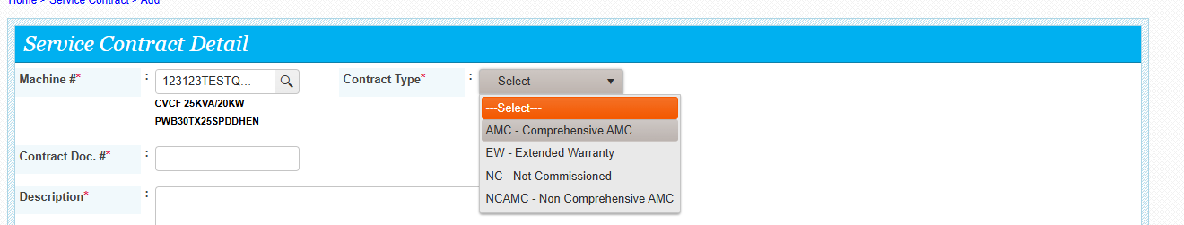

System fetch the data ,

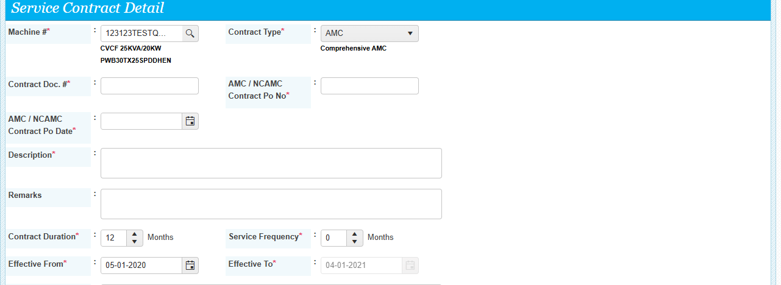

Contract duration is editable

Service frequency ( total no of visits can be entered in this box)

Effective from date is editable .

Enter the contract docmnet details , PO No , PO Date.description and submit

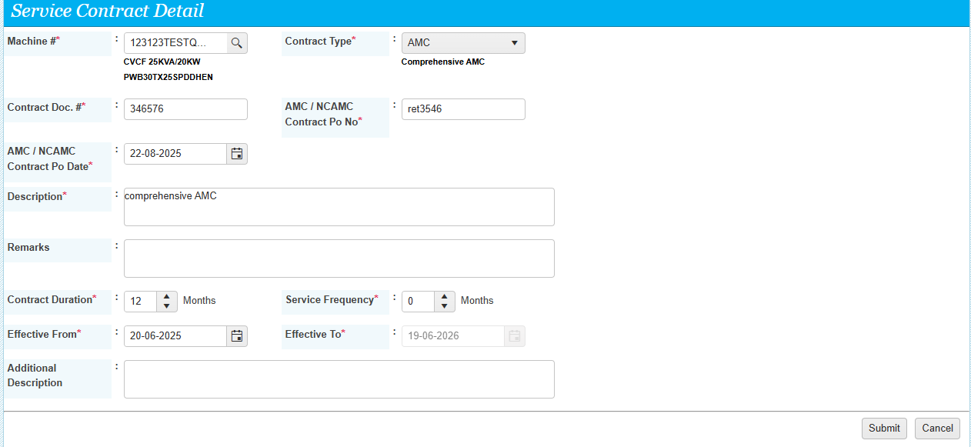

Contract details saved successfully

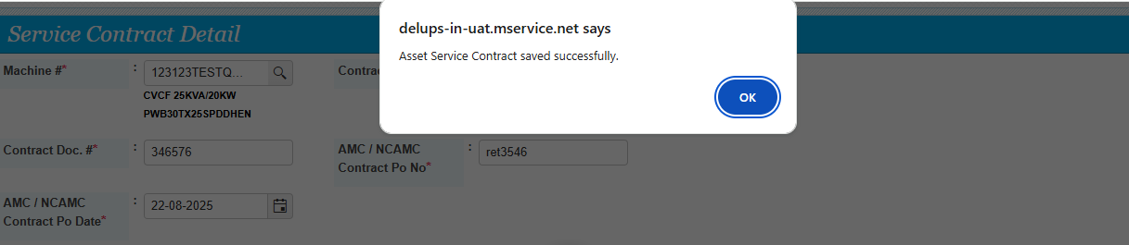

Contract data retrieve and export is possible.